WEEK 6: SIMULATE THE LIFECYCLE STAGES FOR UI DESIGN USING THE RAD MODEL AND DEVELOP A SMALL INTERACTIVE INTERFACE USING AXURE RP
V Roshini | 230701270 | CSE-FC

AIM: The aim is to demonstrate the lifecycle stages of UI design via the RAD model and develop a small interactive interface employing Axure RP.

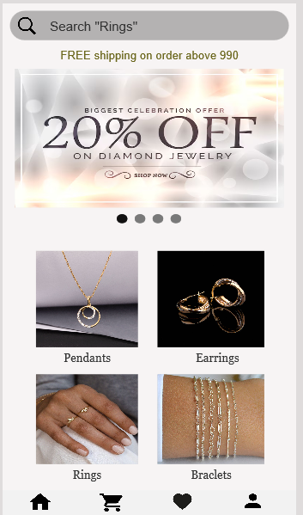
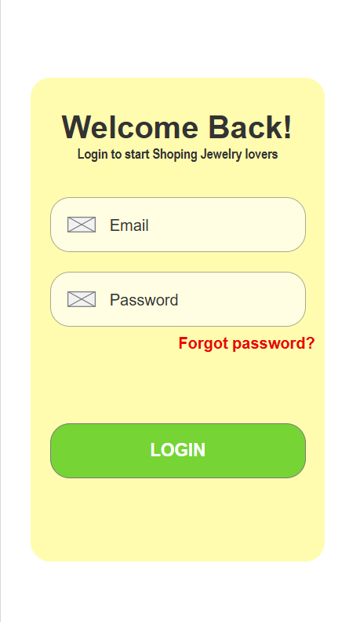

1. Requirements Planning Phase
In this phase, we identify and define the goals, user needs, and system requirements for the UI.
- Objective:
Develop an interactive jewelry shopping interface with key features such as login, product browsing, and promotional offers.
- Key Requirements:
  - User login with email and password.
  - Password recovery option.
  - Display of promotional banners.
  - Search functionality (e.g., search for “rings”).
  - Product display categories (e.g., pendants, earrings, bracelets).
- Stakeholders Involved:
  - UI/UX designer.
  - Project manager.
  - End-users (for feedback).
  - Developer (working with Axure RP).

2. User Design Phase
This phase focuses on building quick prototypes and designing the user interface, collecting user feedback along the way.
- Activities:
  - Create wireframes and mockups for the login screen and product browsing screen using Axure RP.
  - Define the layout, including input fields, buttons, and navigation elements.
  - Integrate interactive elements (e.g., clickable login button, search bar functionality).
  - Incorporate user feedback to refine layouts and improve usability.
- Prototypes Developed:
  - Login screen (as shown in the left image):
Includes welcome text, email and password fields, “forgot password” link, and a login button.
  - Product browsing screen (as shown in the right image):
Includes a search bar, promotional banner, and clickable product categories like pendants, earrings, bracelets.
- Tools:
Axure RP for interactive prototypes, allowing clickable flows and dynamic elements.

3. Construction Phase
In this phase, the actual interface is developed rapidly, based on the approved design prototypes.
- Tasks:
  - Build the interactive login form, connecting input fields to basic validation.
  - Implement product categories with navigation links.
  - Set up the promotional section with dynamic image content.
  - Integrate search functionality mockups (not fully functional search engine, but interface-wise ready).
  - Ensure visual consistency, color schemes, and branding.
- Focus:
Speed of development, iterative feedback, and continuous adjustments in Axure RP.

4. Cutover Phase
This is the final phase where the system is tested, finalized, and prepared for handover.
- Activities:
  - Conduct UI testing to ensure all buttons, links, and interactions work as intended.
  - Perform user walkthroughs to check flow and ease of navigation.
  - Final adjustments based on feedback.
  - Prepare documentation and finalize the prototype for client presentation or further development.

